Title Title Title Title Title Title Title Title Title Title Title Title Title Title Title Title Title Title Title Title Title Title

SURNAME N.¹, SURNAME N.¹, SURNAME N.², SURNAME N.²
1Affiliation and address
²Affiliation and address

Text text text text text text text text text text text text text text text text text text text text text text text text text text text text text text text text text text text text text text text text text text text text text text text text text text text text text text text text text text text text text text text text text text text text text text text text text text text text text text text text text text text text text text text text text text text text text text text text text text text text text text text text text text text text text text text text text text text text text text text text text text text text text text text text text text text text text text text text text text text text text text text text text text text text text text text text text text text text text text text text text text text text text text text text text text text text text text text text text text text text text text text text text text text text text text text.

Keywords: Up to 5 keywords

Table 1. Title of the table
Text | Text
Text | Text
Text | Text
Text | Text
Text | Text
Text | Text
Text | Text
Text | Text

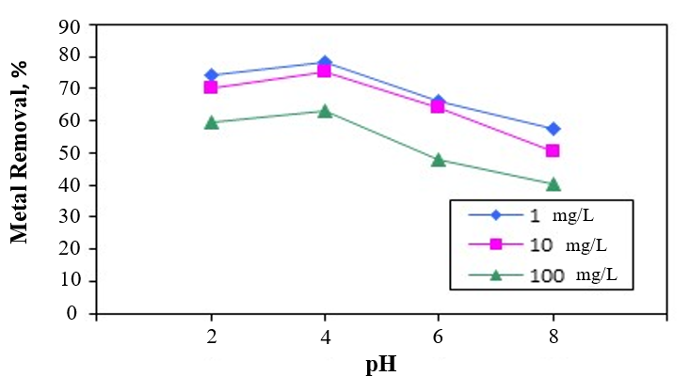
Figure 1. (example) Effect of pH for the removal of Pb (II) onto diatomite

References (examples)
Aguado J., Arsuaga J.M., Arencibia A., Lindo M. & Gascón V. (2009), Aqueous heavy metals removal by adsorption on amine-functionalized mesoporous silica, Journal of Hazardous Materials, 163 (1), 213-221.
Allen S.J., McKay G. & Khader K.Y.H. (1989), Intraparticle diffusion of a basic dye during adsorption onto Sphagnum Peat, Environmental Pollution, 56, 39-50.

